COHORT ANALYSIS WITH PYTHON AND POWER BI

What is Cohort Analaysis?

Cohort analysis is a kind of behavioral analytics that breaks the data in a data set into related groups before analysis. These groups, or cohorts, usually share common characteristics or experiences within a defined time-span.Cohort analysis allows a company to "see patterns clearly across the life-cycle of a customer (or user). By seeing these patterns of time, a company can adapt and tailor its service to those specific cohorts.

Types of Cohorts

1- Time-Based Cohorts

Time-based cohorts are customers who signed up for a product or service during a particular time frame. Analyzing these cohorts shows the customers’ behavior depending on the time they started using a company’s products or services. The time may be monthly or quarterly, depending on the sales cycle of a company.

2- Segment-Based Cohorts

It groups customers by the type of product or level of service they signed up for. Customers who signed up for basic level services might have different needs than those who signed up for advanced services. Understanding the needs of the various cohorts can help a company design tailor-made services or products for particular segments.

3- Size -Based Cohorts

Size-based cohorts refer to the various sizes of customers who purchase a company’s products or services. The customers may be small and startup businesses, middle-sized businesses, and enterprise-level businesses. Comparing the different categories of customers based on their size reveals where the largest purchases come from.

Cohort Analysis with and without Amazon Sales

In this analysis, we will initially use the entire sales data. However, since it includes Amazon sales and represents all Amazon customers as one (C0000001), we will eliminate Amazon sales and customer "C0000001" in our second analysis.

1- Customers who have purchased multiple times:

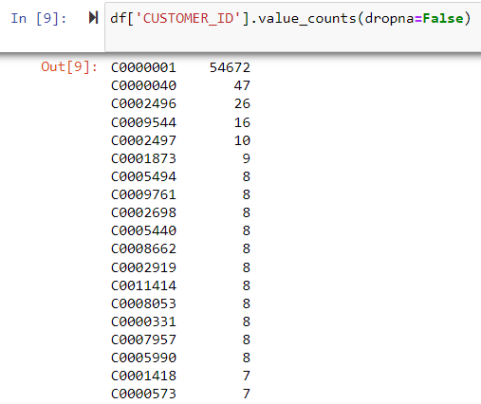

Insights:

1. Out of 92249 records, 54672 orders come from customer "C0000001" representing Amazon customers.

2. The second best customer is "C0000040". But when we check the customer "C0000040" from the original Sales data, almost half of the company columns have "Student". So, it is a group of people but not a specific customer.

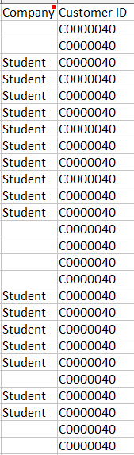

2- Our first customers (in November 2019):

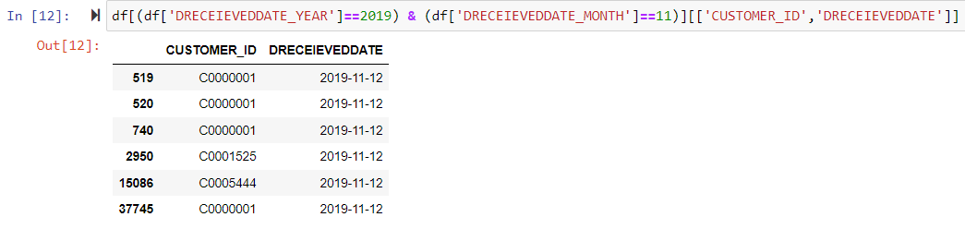
Insights:

1. In the beginning, we had only three different customers: “C0000001” , “C0001525 ”, “C0005444 ” and one of them represents Amazon customers.

2. As seen above, there are a few Amazon records in the first month. So, if we exclude Amazon sales, we will lose only one customer (C0000001) in Cohort Analysis in November 2019. Other months will not be affected because the first record for each customer is included in this analysis. Apart from that, Cohort Analysis without Amazon Sales will not make any difference and will resemble the tables and graphs below.

3- Create a Cohort Index for 38 months to see customer life-cycle

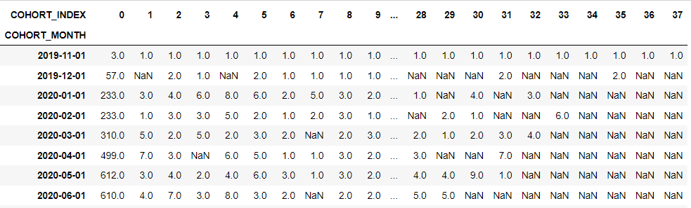

Insights:

As seen above, the company had only 3 customers in the beginning and it could achieve to retain only one customer among them, namely, Amazon customers (C0000001). In other words, other customers were one-time customers and left the company in the following month. So, the retention rate is 33 % and the churn rate is 66 % for November 2019 customers.

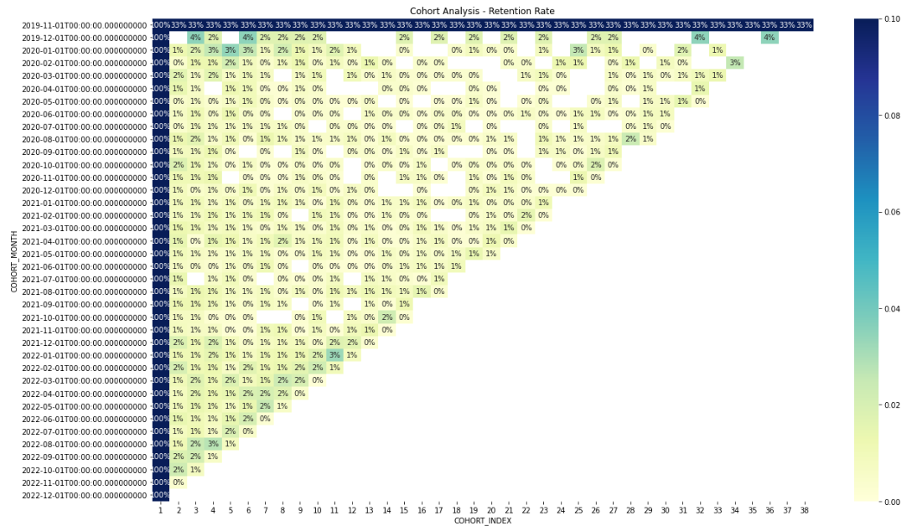
Insights:

Retention rates in general are very low regardless of month and year. Rarely, 3% and 4% of our customers continue shopping. The majority of these are customers who bought products from the company in December 2019. The customers who met the company during this period seem to be the most loyal customers.

One reason why the company has low retention rates or high churn rates is the lack of variety of products sold by the company since it is a rug company. Also, they sell a product (rugs and carpets) that customers can use for many years when they buy them. So it takes a long time for a customer to return. As a result, Cohort Analysis does not give valuable insights for the company unless it diversifies the products it sells.

4- Average Quantity Sold by These Customers

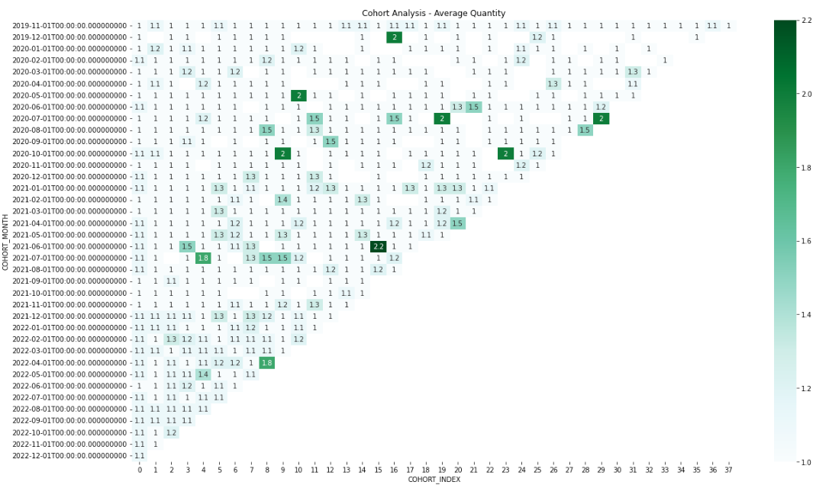
Insights:
The graph above reveals that loyal customers buy between 1 - 2.2 items on average. The reason is that a customer can buy a limited number of rugs and use them for a long time.

5- Cohort Analysis without Amazon Sales by using Power BI

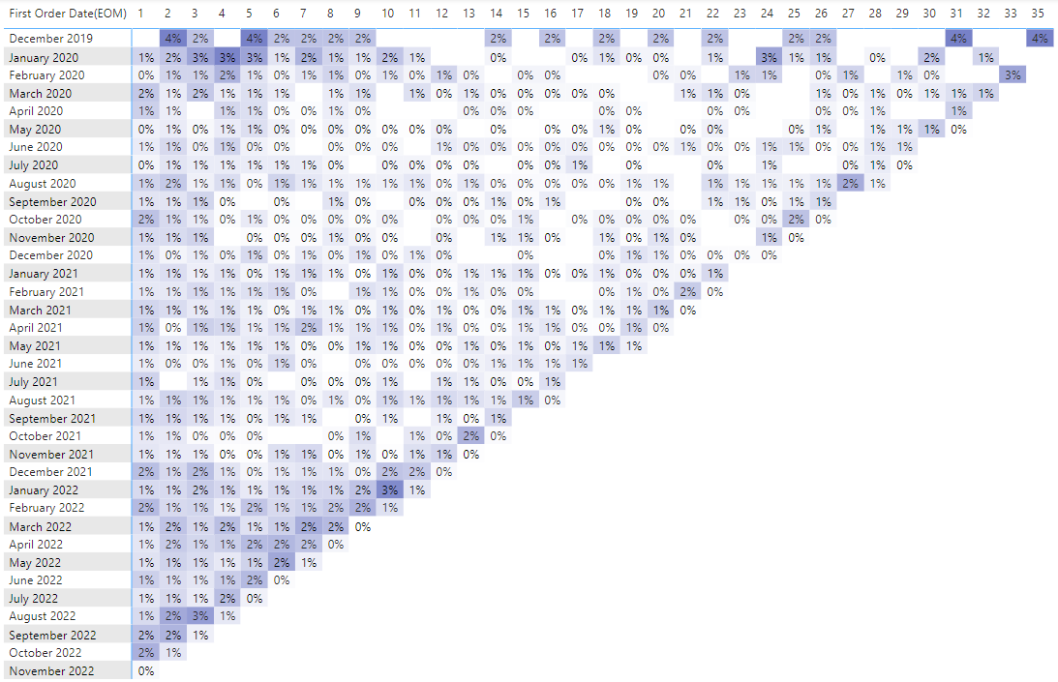
Insights:
1. When we exclude Amazon Sales and the first month the customers buy for the first time in our company, we see that November 2019 customers disappear. The reason is that no other customer continues shopping except Amazon customers.
2. When we check the months for above 1 %, we see that customers return mostly around November. Campaigns before Christmas and Black Friday may cause to return customers during this time of the year. The cell before the last one for each month represents November and we can detect a cross line for November across the graph.
3. Lastly, December 2019 and January 2020 customers seem the most loyal customers.

